**Primary Care referral Form**

Please complete the following form to refer to the CEW clinic.

* Primary care referrals are currently **only being accepted from clinicians** in general practice.
* Patients should be **assessed for complications** and, where identified, should be **referred according to the usual pathways**, with consideration of a **dual referral to CEW**, if appropriate.
* Patients must be **motivated to change** (the exception being if this referral forms part of a Child Protection Plan where obesity is the main concern, in which please discuss with us prior to referral).
* We understand that it may not be possible to undertake all suggested investigations in some patients (e.g. those with neurodiversity) and, where this is the case, it need not delay the referral, but **please mention this in the referral**. Identification of complications will help ensure patients are seen in the most appropriate order.
* Please ensure your patients are aware that there may be a long delay till they are offered an appointment and some patients may not be seen.

Please email your completed referral to [cew.obesityem1@nhs.net](mailto:cew.obesityem1@nhs.net)

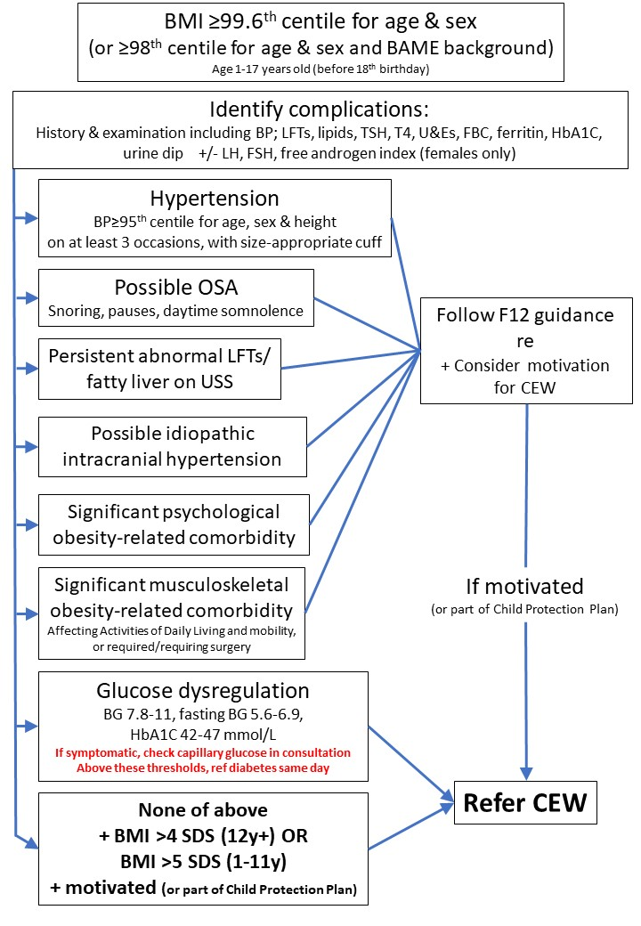

Referrals are for accepted if the child or young person:

* Is **aged 1-17 years** (before 18th birthday)
* Has **agreed** to the referral and are motivated to engage with the service (unless part of a child protection plan)
* Fits the criteria **A OR B below**

|  |  |  |  |  |  |
| --- | --- | --- | --- | --- | --- |
|  | **SECTION 1 - PATIENT DEMOGRAPHIC DETAILS** | | | | **MOBILITY & COMMUNICATION** |
| **Title:** <Patient Name> | | **FIRST NAME:** <Patient Name> | | **Mobility****:**      <Diagnoses> |
| **Date of Birth:** <Date of birth> | | **SURNAME:** <Patient Name> | | **Tick if Transport required : Y** |
| **Age**: **<Patient Age>** | **Gender: <Gender>** | **NHS number:** <NHS number> | | **Language:** <Diagnoses> |
| **Ethnicity:** <Diagnoses> | | **Carer status:**       <Diagnoses> | | **Tick if Interpreter required?: Y** <Diagnoses> |
| **Contact Details:**  _ Please check these are up to date  <Patient Contact Details> | | | | **Tick if Communication / Capacity issues:** **Y**  <Diagnoses> |
| **Address:** <Patient Address>  **Patient School :** <Patient School> | | | | **Accessible Information Standards:**  <Diagnoses> |
| **Name of parent / guardian:** <Relationships> | | | **Please indicate who has parental responsibility:** | |
| **1a – PRACTICE INFORMATION** | | | | |
| **Referring GP** | | | | **Date of Referral:** <Today's date> |
| **Practice Address:** <GP Details> | | | | |
| **Telephone:** <GP Details> | | | | |

|  |  |  |  |
| --- | --- | --- | --- |
|  | A | 12 years old and over: BMI SDS ≥ 4 standard deviation score (SDS)  1-11 years old: BMI SDS ≥ 5 SDS  [www.rcpch.ac.uk/sites/default/files/2018-03/boys_and_girls_bmi_chart.pdf](http://www.rcpch.ac.uk/sites/default/files/2018-03/boys_and_girls_bmi_chart.pdf) | |
| B | BMI SDS ≥ 2.67 SDS (99.6th centile) (*or* ≥2.0 SDS / 98th centile for BAME patients) (see growth chart link above)  **and one or more of the below:** | |
| • One or more co-morbidities related to excess weight: | **Tick as appropriate** |
| Suspected MASLD (previously called NAFLD) (ALT ≥2x upper limit normal or abdominal US consistent with MASLD) |  |
| Pre diabetes (e.g. HbA1c 41-47 mmol/mol), (fasting glucose 5.6-6.9, random glucose 7.8-11)  If symptoms of diabetes, check a point-of-care finger-prick glucose level and, if diabetes confirmed refer same day to the local paediatric diabetes team. Children under-18 with any type of diabetes must be under secondary care |  |
| Obstructive sleep apnoea (confirmed on sleep study) |  |
| Joint/mobility problems (requiring surgery or activities of daily life significantly limited) |  |
| Hypertension (above 95th centile for age, sex and height or above 130/80) |  |
| Idiopathic intracranial hypertension (requiring treatment) |  |
| Dyslipidemia (Cholesterol ≥7 or fasted triglycerides ≥5) |  |
| Significant psychological co-morbidity |  |
| • Confirmed genetic cause of obesity |  |
| • Secondary cause of obesity (pituitary surgery, hypothalamic dysfunction) |  |
| • Child protection plan (only where primarily for obesity) |  |
| • Being considered for bariatric surgery |  |

|  |  |  |  |  |  |
| --- | --- | --- | --- | --- | --- |
|  | **FBC** | <Numerics> | Hb <Numerics>, WCC <Numerics>, Plts <Numerics>, MCV <Numerics>, Neut <Numerics> | | |
| **UE** | <Numerics> | Na <Numerics>, K <Numerics>, Urea <Numerics>, Creat <Numerics>, eGFR <Numerics> | | |
| **LFT** | <Numerics> | ALT <Numerics>, Alk Phos <Numerics>, Bili <Numerics>, Alb <Numerics>, GGT <Numerics>, Serum globulin <Numerics>, Total Protein <Numerics> | | |
| **CRP** | <Numerics> | <Numerics> | **ESR** | <Numerics> |
| **TFTs** | <Numerics> | TSH <Numerics>, Free T4 <Numerics> | **INR** | <Numerics> |
| **Iron** | <Numerics> | Ferritin <Numerics>, Iron Saturation <Numerics>, TIBC <Numerics> | | |
| **Lipids** | <Numerics> | Chol <Numerics>, LDL <Numerics>, HDL <Numerics>,Chol:HDL ratio <Numerics>, Tri <Numerics> | | |
| **Random Glucose** | | <Numerics> | **Fasting Chol.** | <Numerics> |
| **Fasting Glucose** | | <Numerics> | **HbA1c** | <Numerics> |
| **BP** | | <Blood Pressure Configurable> | <Numerics> <Numerics> | |

|  |  |
| --- | --- |
|  | **SECTION 3 - PAST MEDICAL HISTORY** |
| **Additional Child Relevant Data:** |
| Current Safeguarding codes:<Diagnoses>  <Diagnoses>  Looked after child status: <Diagnoses> |
| Height: <Numerics(table)>  <Numerics(table)> |
| Weight: <Numerics(table)>  <Numerics(table)> |
| BMI : <Numerics(table)> |
| Head Circum’ <Numerics(table)> |
| **PROBLEMS / SUMMARY** |
| **Please delete either problem entries or summary entries on this form depending on which system your practice uses:**  **These are the problem entries:**  **Major Problems**  <Problems(table)>  **Minor Problems**  <Problems(table)>  **These are the summary entries:**  **Major Summary**  <Summary(table)>  **Minor & Unspecified Summary**  <Summary(table)> |
| **MEDICATION** |
| **Current Repeats Medication**  <Repeat Templates(table)>  **Current Acute Medication:** (this will show hospital / dental medications if added to Systmone)  <Medication(table)> |
| **ALLERGIES AND SENSITIVITIES** |
| <Allergies & Sensitivities(table)> |
| **IMMUNISATIONS (any blanks indicate missing immunisations)** |
| **<Childhood Immunisations Grid(table)>** |

Please email your completed referral to [**cew.obesityem1@nhs.net**](mailto:cew.obesityem1@nhs.net)