Welcome to CEW’s Summer of Fun

All these activities are free of charge

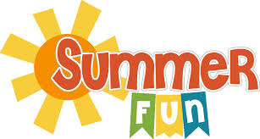

There are lots of events happening all over the city that are free of charge, below are just some ideas for you and your family to enjoy and get active over the summer. Lots of lovely walks and fun.

Lark in the Park – 6th August at Bridgford Park, West Bridgford.

Wollaton Hall and Gardens – Wollaton Road, Nottingham NG82AE

Highfields Park – University Boulevard, Nottingham NG72RD

Attenborough Nature reserve – 52 barton lane Beeston NG96DY

Nottingham Beach in the City – Nottingham City Centre

Greens Mill and Science Centre, Windmill Lane, Nottingham NG2 4QB

The Embankment Children’s Paddling Pool and Play Park – Victoria Embankment, Nottingham NG2 2AA

The Forest Recreation Ground, Playground and Football – Gregory Boulevard, Nottingham NG76HB